BADIRA · WEEK 1 OF 4 · TASK 2
Finding the Data
Candidate datasets for the preeclampsia task, assessed and ranked
Dana Al Mounayer & Jwdee Alimam · Supervisor: Dr. Naila Marir · Clinical collaborator: Dr. Rania
HEADLINE FINDING
Three of the strongest datasets — nuMoM2b [1], MFMU HRA [2] and MFMU LRA [3] — are all available through the same repository, the NICHD Data and Specimen Hub (DASH) [9]. One application, one Data Use Agreement [10] and one authorised university signature [11] reach all three.
They also cover different population gaps. LRA focuses on low-risk nulliparous women [3], while HRA focuses on high-risk pregnancies and includes 606 women with previous preeclampsia [2]. Because nuMoM2b enrolled nulliparous women [1], it cannot provide prior pregnancy history within its enrolled population — which is exactly the gap HRA fills.

Table 1 — The datasets at a glance
Dataset | Origin | Size | Preeclampsia recorded | Access
MFMU HRA — High-Risk Aspirin [2] | US — NICHD MFMU randomized trial | 2,539 randomized | Yes, 606 | NICHD DASH [9]; DUA required [10]
MFMU LRA — Low-Risk Aspirin [3] | US — NICHD MFMU randomized trial | 3,135 nulliparous women | Yes — trial outcome | NICHD DASH [9]
nuMoM2b [1] | US — 8 clinical centers, 2010–2013 | 10,037 enrolled | Yes — primary outcome | NICHD DASH [9]
RAHMA [4] | Saudi — 3 Riyadh hospitals | 14,568 women | Yes ,1.2% PE ~ 175 | Restricted; access approval required
Dr. Rania’s hospital records | Saudi — local, single center | Unknown — confirm | Availability and coding need confirmation | Discuss with Dr. Rania; IRB likely required
Mutaba’ah Study [5] | UAE — Al Ain; UAEU + 3 hospitals | 10,565 recruited | Not confirmed | By reasonable request; ethics may be required
Qatar Birth Cohort (QBiC) [6] | Qatar — MOPH, Qatar Biobank & partners | 3,000 target | Not confirmed | QPHI Research Portal [12]
Dryad — metformin trial [8] | High-risk pregnancy trial | 410 listed | Listed as PE outcome | Open download; contents need verification

What each dataset actually is
Table 1 gives names and numbers. This section says, in plain words, what each dataset is, who was in it, and what it can and cannot do for this project.
nuMoM2b [1] — US, 10,037 women, 2010–2013
The full name is Nulliparous Pregnancy Outcomes Study: Monitoring Mothers-to-Be. It followed 10,037 women who were pregnant for the first time, across eight hospitals in the United States [1].
Its strongest feature is timing: each woman was seen three times during pregnancy and again at delivery [1]. That means the data records how a woman changed over her pregnancy, not a single snapshot — which is what a risk-over-time model needs. Preeclampsia was a main outcome of the study, so the labels are carefully defined.
Its weakness follows directly from its design. Because every woman is in her first pregnancy, fields such as previous preeclampsia, previous preterm birth, previous gestational diabetes and parity are empty or the same for everyone. Those are among the strongest predictors in the clinical checklist, and a model trained here can never learn them.
MFMU HRA — High-Risk Aspirin trial [2] — US, 2,539 women
A randomized trial run by the NICHD Maternal-Fetal Medicine Units Network [2]. Every woman in it was already known to be at high risk, in four groups: chronic hypertension, pregestational diabetes, multiple pregnancy, and — most importantly for us — 606 women who had preeclampsia in a previous pregnancy [2].
Because the population is deliberately enriched with high-risk women, the number of preeclampsia cases is large relative to the size of the cohort. And because it is a trial, the outcome was formally adjudicated rather than read off a medical record, so the labels are clean.
It fills precisely the gap that nuMoM2b [1] leaves open.
MFMU LRA — Low-Risk Aspirin trial [3] — US, 3,135 women
The same research network, but the opposite population: 3,135 healthy first-time mothers with normal blood pressure, enrolled between 13 and 26 weeks [3]. Outcomes were adjudicated, as in HRA.
It is useful as a contrast group — a low-risk population measured the same way as the high-risk one — and it costs nothing extra to obtain, because it sits in the same repository [9].
RAHMA [4] — Saudi Arabia, 14,568 women
A Saudi cohort collected across three Riyadh hospitals of different types: university, military and Ministry of Health [4]. This is the best population match for the women BADIRA is being built for.
The difficulty is the case count. The reported preeclampsia rate is 1.2% [4], which gives roughly 175 cases from 14,568 women. It is the largest cohort on this list and the one with the smallest number of usable cases.
For context, a Saudi meta-analysis reports a national preeclampsia prevalence of 4.80% [7], so RAHMA’s 1.2% is likely to be measuring something narrower than all hypertensive disorders of pregnancy. This should be checked before the figure is quoted.
Dr. Rania’s hospital records — Saudi Arabia, single centre, size unknown
Local records reachable through the clinical collaborator already working with this project. The advantage is the route: a person rather than an application portal.
Nothing about it is confirmed yet — not the number of women, not whether preeclampsia is coded in a usable way, not what ethics approval would be required. Those are the first questions to ask.
Mutaba’ah Study [5] — UAE, Al Ain, 10,565 women
An Emirati mother-and-child cohort run by UAE University with three hospitals. Women were recruited at about 12 weeks of pregnancy [5] — exactly the window in which first-trimester prediction happens.
It is an Arab population, which matters for how well a model transfers. But whether preeclampsia is recorded, and how, is not yet confirmed, and access requires a collaboration request rather than a download [5].
Qatar Birth Cohort (QBiC) [6] — Qatar, about 3,000 women targeted
A national birth cohort run by the Ministry of Public Health with Qatar Biobank [6]. Another Arab population, which is valuable.
The cohort is small, so even a normal preeclampsia rate would leave a case count in the low double digits — too few to train on alone, though potentially useful for testing whether a model transfers. Access is through the QPHI Research Portal [12].
Dryad — metformin prevention trial [8] — 410 women, openly downloadable
A published trial in high-risk pregnancy whose data is deposited on Dryad and can be downloaded immediately, with no application and no agreement [8]. Preeclampsia is listed as an outcome.
It is far too small to be the main dataset. Its value is practical: it is real obstetric data we can have today, so the preprocessing pipeline and the Data Profiler can be built and tested on it while the applications for the larger datasets are still pending.

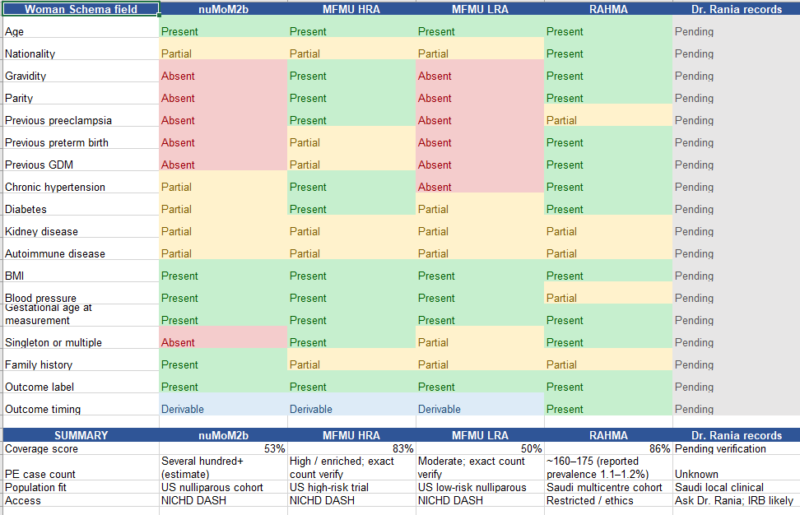

The number that decides: preeclampsia case counts
Row count is not sample size. The number of women who actually developed preeclampsia is what limits any model.

Table 2 — Estimated preeclampsia case counts
Dataset | Women | PE cases | Basis
nuMoM2b [1] | ~10,000 | Several hundred+ (est.) | Inferred from cohort size and a general-population rate; the exact adjudicated count must be confirmed from the data dictionary
MFMU LRA [3] | 3,135 | Moderate | Low-risk nulliparous population; trial-adjudicated outcome
MFMU HRA [2] | 2,539 | High — enriched | High-risk population by design; 606 women with previous preeclampsia [2]
RAHMA [4] | 14,568 | ~175 (calc.) | 14,568 × the reported 1.2% prevalence [4]
Mutaba’ah [5] | 10,565 | Unknown | Recruited at ~12 weeks [5]; preeclampsia recording not yet confirmed
QBiC [6] | ~3,000 | Low (est.) | Small cohort; at any normal prevalence the count is likely double digits
Dryad metformin [8] | 410 | ~60–80 (est.) | Our estimate at 15–20% incidence in a high-risk trial population — not a published figure
UCI [14] | 1,014 | 0 | No preeclampsia outcome exists in the file [14]

NOTE ON THE ESTIMATES
Only the RAHMA figure is calculated from a published number [4]. The nuMoM2b, QBiC and Dryad case counts are our own estimates, made to rank the candidates, and are marked “est.” above. Each must be replaced with the true adjudicated count once the data dictionaries are in hand.

Checked and excluded
Table 3 — Datasets examined and set aside
Dataset | What it is | Why excluded
UCI Maternal Health Risk [14] | 1,014 rows; age, systolic BP, diastolic BP, blood sugar, temperature, heart rate + a generic three-level risk label | No gestational age, no obstetric history, and no specific preeclampsia outcome. It cannot answer the question we are asking.
Kaggle — Maternal Health and High-Risk Pregnancy [15] | An uploaded maternal-health dataset, updated July 2026 | No clear data source or publication. Provenance cannot be verified, so nothing built on it could be defended.

The two datasets we recommend
Nine datasets were examined. Two are worth applying for first, and they are chosen as a pair rather than individually — because each one covers the other’s weakness.
First choice — MFMU HRA (High-Risk Aspirin trial) [2]
Because the number of preeclampsia cases is the binding constraint, and this is the only dataset that was deliberately built to contain them.

• Every woman in it was already high-risk [2], so the proportion who develop preeclampsia is far higher than in a general cohort. A smaller file can therefore carry more usable cases than a much larger one — compare its 2,539 women with RAHMA’s 14,568 and roughly 175 cases [4].
• It contains 606 women with preeclampsia in a previous pregnancy [2]. Previous preeclampsia is the single strongest factor on the clinical checklist, and it is the field nuMoM2b [1] structurally cannot provide.
• The outcome was adjudicated as part of a randomized trial [2], not extracted from routine notes, so the labels are as clean as this field gets.
• It is held on NICHD DASH [9], which is an application and a data use agreement [10] — a defined process with a known route, not an open-ended negotiation.
Second choice — nuMoM2b [1]
Because it is the only candidate with real measurements over time, which is what a risk-over-time model requires.

• Three antenatal visits plus delivery for each woman [1]. Most cohorts record one snapshot; this one records a trajectory, which is what BADIRA is designed to predict.
• It is the largest well-documented cohort on the list, with preeclampsia as a primary study outcome and full published methods [1].
• Its known weakness — nulliparous by design, so six of the eighteen Woman Schema fields are empty or constant — is exactly what HRA [2] supplies. The two together cover both populations and both halves of the schema.

Why this pair, and not any other
nuMoM2b [1], MFMU HRA [2] and MFMU LRA [3] are held in the same repository [9]. One application, one Data Use Agreement [10] and one authorised signature from the university [11] reach all three.
That is the most important practical fact in this task. The two recommended datasets cost the same effort to obtain as one, and LRA comes with them at no additional cost.

Sources
Cited in the text and tables as [1] to [15].
Study publications and datasets
1. Haas DM, Parker CB, Wing DA, et al. A description of the methods of the Nulliparous Pregnancy Outcomes Study: Monitoring Mothers-to-Be (nuMoM2b). American Journal of Obstetrics and Gynecology. 2015;212(4):539.e1–539.e24. See also the NICHD nuMoM2b study page.
2. Caritis S, Sibai B, Hauth J, et al. Low-dose aspirin to prevent preeclampsia in women at high risk. New England Journal of Medicine. 1998;338:701–705. (MFMU High-Risk Aspirin trial.)
3. Sibai BM, Caritis SN, Thom E, et al. Prevention of preeclampsia with low-dose aspirin in healthy, nulliparous pregnant women. New England Journal of Medicine. 1993;329:1213–1218. (MFMU Low-Risk Aspirin trial.)
4. RAHMA cohort profile. PLOS ONE. 2016. doi:10.1371/journal.pone.0150297. (Riyadh mother-and-baby multicentre cohort; source of the 14,568 figure and the 1.2% preeclampsia rate.)
5. Mutaba’ah Study cohort profile. Population Medicine. Study protocol published in BMJ Open. (UAE, Al Ain; UAE University with three hospitals.)
6. Qatar Birth Cohort (QBiC) phase I. BMC Public Health. 2017.
7. Nujoom et al. Prevalence of preeclampsia in Saudi Arabia: a meta-analysis. Cureus. 2025. (4.80% prevalence; 27% awareness.)
8. Metformin for the prevention of preeclampsia — trial data deposited in the Dryad Digital Repository.
Repositories and access routes
9. NICHD Data and Specimen Hub (DASH) — the repository holding nuMoM2b, MFMU HRA and MFMU LRA. dash.nichd.nih.gov
10. DASH — How to request data; Data Use Agreement (PDF); Data request checklist (PDF).
11. DASH — Authorized Organization Representative (AOR) guide (PDF): who at the university must sign the agreement.
12. Qatar Biobank / QPHI Research Portal — access route for QBiC.
13. Global Pregnancy Collaboration (CoLab) and the COLLECT database — searched for further candidate cohorts.
Datasets examined and set aside
14. UCI Machine Learning Repository — Maternal Health Risk dataset. Excluded: no gestational age, no obstetric history, no preeclampsia outcome.
15. Kaggle — Maternal Health and High-Risk Pregnancy dataset, updated July 2026. Excluded: provenance not verifiable.

